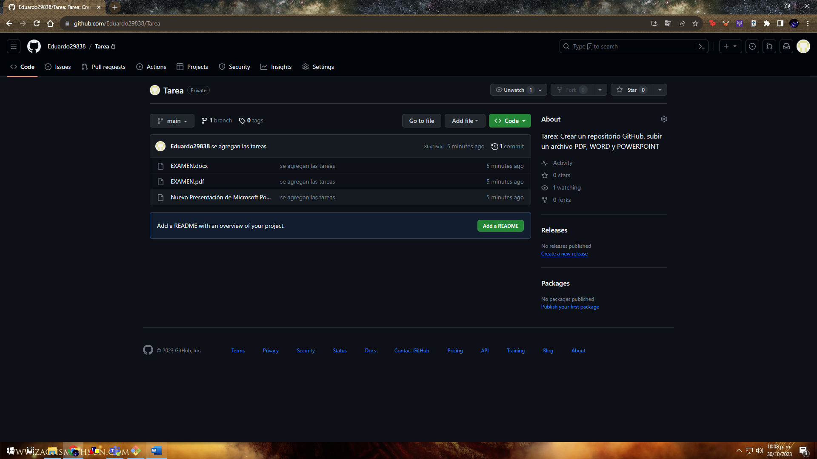

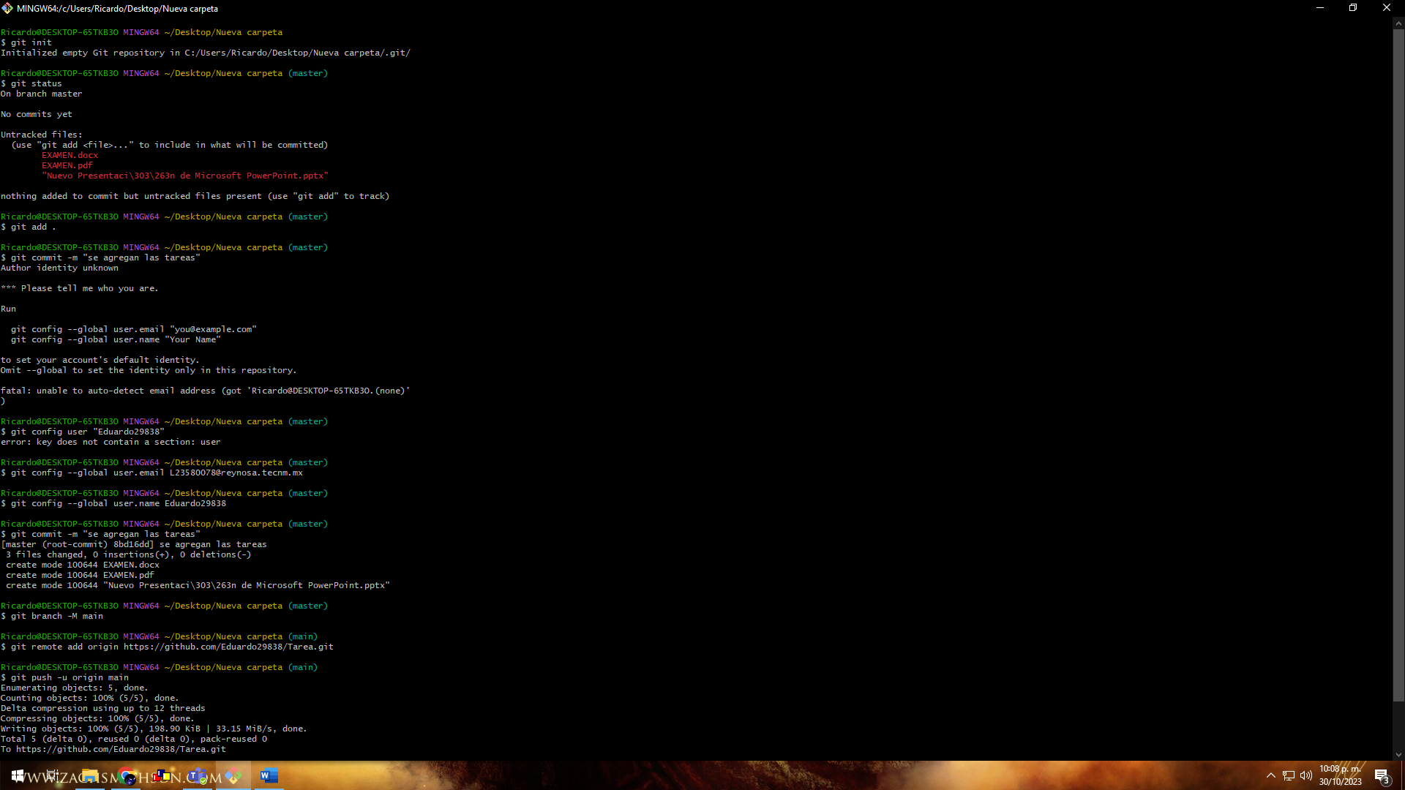

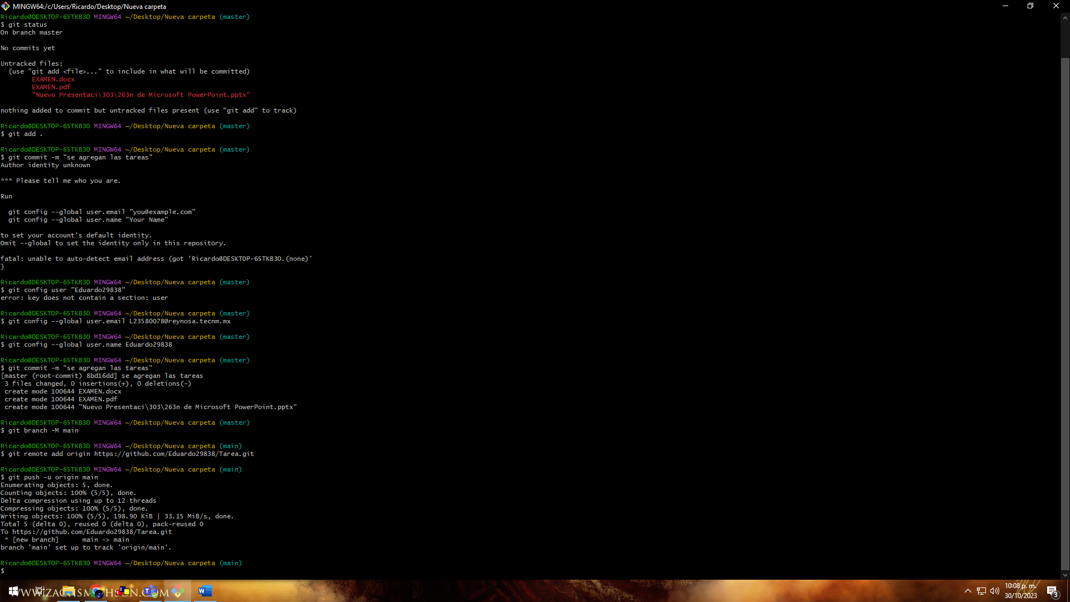

Ricardo@DESKTOP-65TKB3O MINGW64 ~/Desktop/Nueva carpeta

$ git init

Initialized empty Git repository in C:/Users/Ricardo/Desktop/Nueva carpeta/.git/

Ricardo@DESKTOP-65TKB3O MINGW64 ~/Desktop/Nueva carpeta (master)

$ git status

On branch master

No commits yet

Untracked files:

(use "git add <file>..." to include in what will be committed)

EXAMEN.docx

EXAMEN.pdf

"Nuevo Presentaci\303\263n de Microsoft PowerPoint.pptx"

nothing added to commit but untracked files present (use "git add" to track)

Ricardo@DESKTOP-65TKB3O MINGW64 ~/Desktop/Nueva carpeta (master)

$ git add .

Ricardo@DESKTOP-65TKB3O MINGW64 ~/Desktop/Nueva carpeta (master)

$ git commit -m "se agregan las tareas"

Author identity unknown

\*\*\* Please tell me who you are.

Run

git config --global user.email "you@example.com"

git config --global user.name "Your Name"

to set your account's default identity.

Omit --global to set the identity only in this repository.

fatal: unable to auto-detect email address (got 'Ricardo@DESKTOP-65TKB3O.(none)')

Ricardo@DESKTOP-65TKB3O MINGW64 ~/Desktop/Nueva carpeta (master)

$ git config user "Eduardo29838"

error: key does not contain a section: user

Ricardo@DESKTOP-65TKB3O MINGW64 ~/Desktop/Nueva carpeta (master)

$ git config --global user.email L23580078@reynosa.tecnm.mx

Ricardo@DESKTOP-65TKB3O MINGW64 ~/Desktop/Nueva carpeta (master)

$ git config --global user.name Eduardo29838

Ricardo@DESKTOP-65TKB3O MINGW64 ~/Desktop/Nueva carpeta (master)

$ git commit -m "se agregan las tareas"

[master (root-commit) 8bd16dd] se agregan las tareas

3 files changed, 0 insertions(+), 0 deletions(-)

create mode 100644 EXAMEN.docx

create mode 100644 EXAMEN.pdf

create mode 100644 "Nuevo Presentaci\303\263n de Microsoft PowerPoint.pptx"

Ricardo@DESKTOP-65TKB3O MINGW64 ~/Desktop/Nueva carpeta (master)

$ git branch -M main

Ricardo@DESKTOP-65TKB3O MINGW64 ~/Desktop/Nueva carpeta (main)

$ git remote add origin https://github.com/Eduardo29838/Tarea.git

Ricardo@DESKTOP-65TKB3O MINGW64 ~/Desktop/Nueva carpeta (main)

$ git push -u origin main

Enumerating objects: 5, done.

Counting objects: 100% (5/5), done.

Delta compression using up to 12 threads

Compressing objects: 100% (5/5), done.

Writing objects: 100% (5/5), 198.90 KiB | 33.15 MiB/s, done.

Total 5 (delta 0), reused 0 (delta 0), pack-reused 0

To https://github.com/Eduardo29838/Tarea.git

\* [new branch] main -> main

branch 'main' set up to track 'origin/main'.

Ricardo@DESKTOP-65TKB3O MINGW64 ~/Desktop/Nueva carpeta (main)

$

